**CSC 482**

**Assignment 1**

**API Selection and Postman**

Jimmy Nguyen

**Name**: Coin Desk

**Description**: API that provides Bitcoin Price Index (BPI) on request. They calculate the BPI in USD, EUR, and GBP (BPI in real-time data).

**URL**: <https://www.coindesk.com/api> OR <https://api.coindesk.com/v1/bpi/currentprice.json>

**Access Type**: Public

**Format of Data**: JSON

**Screenshot of Postman (with API request of endpoints/results)**:

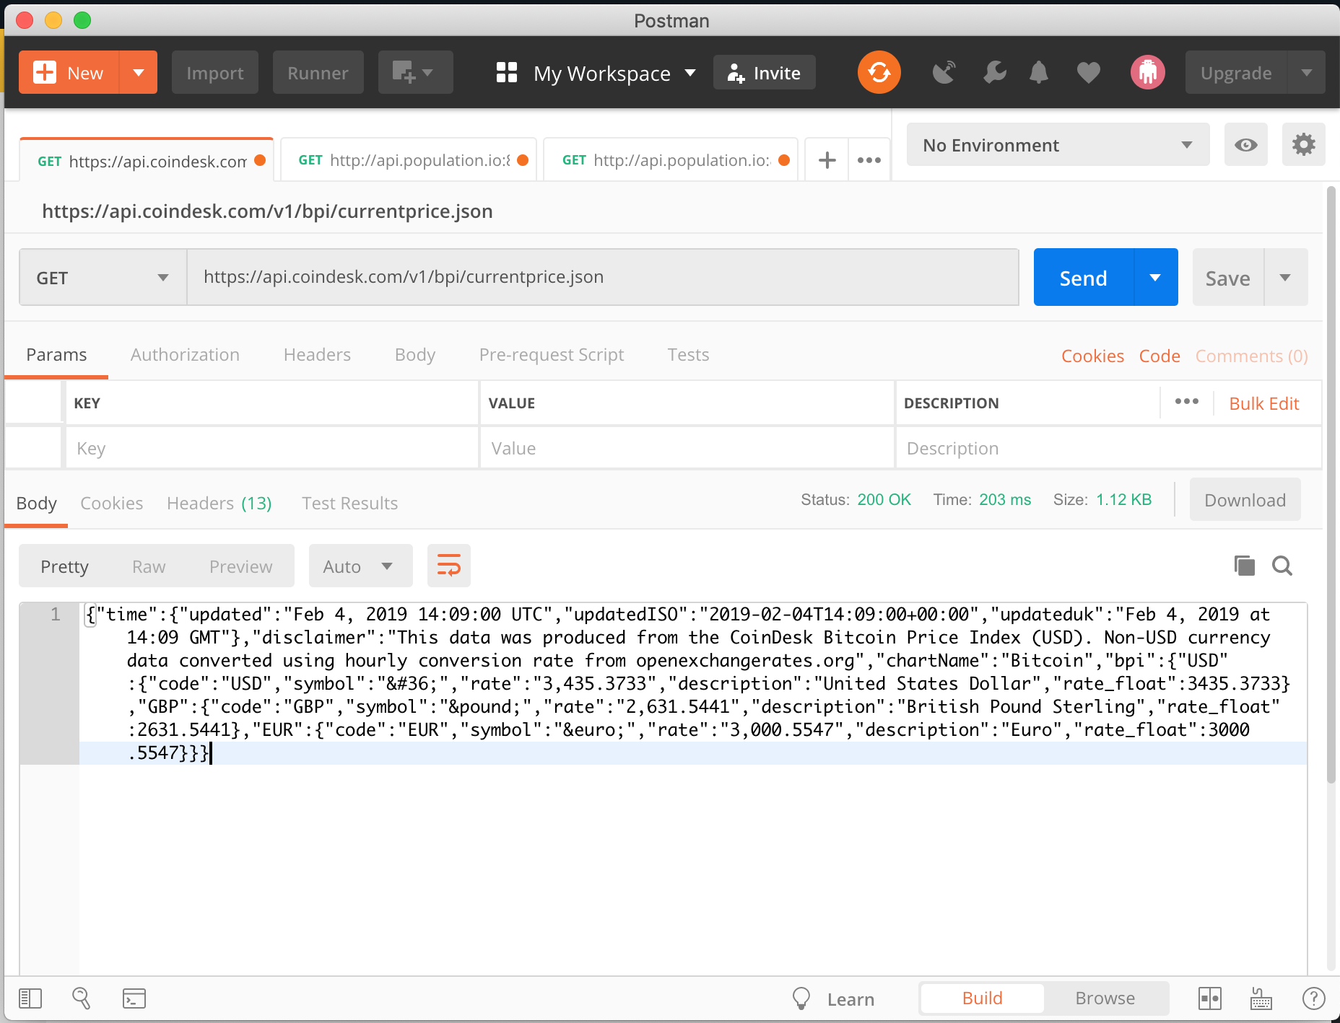

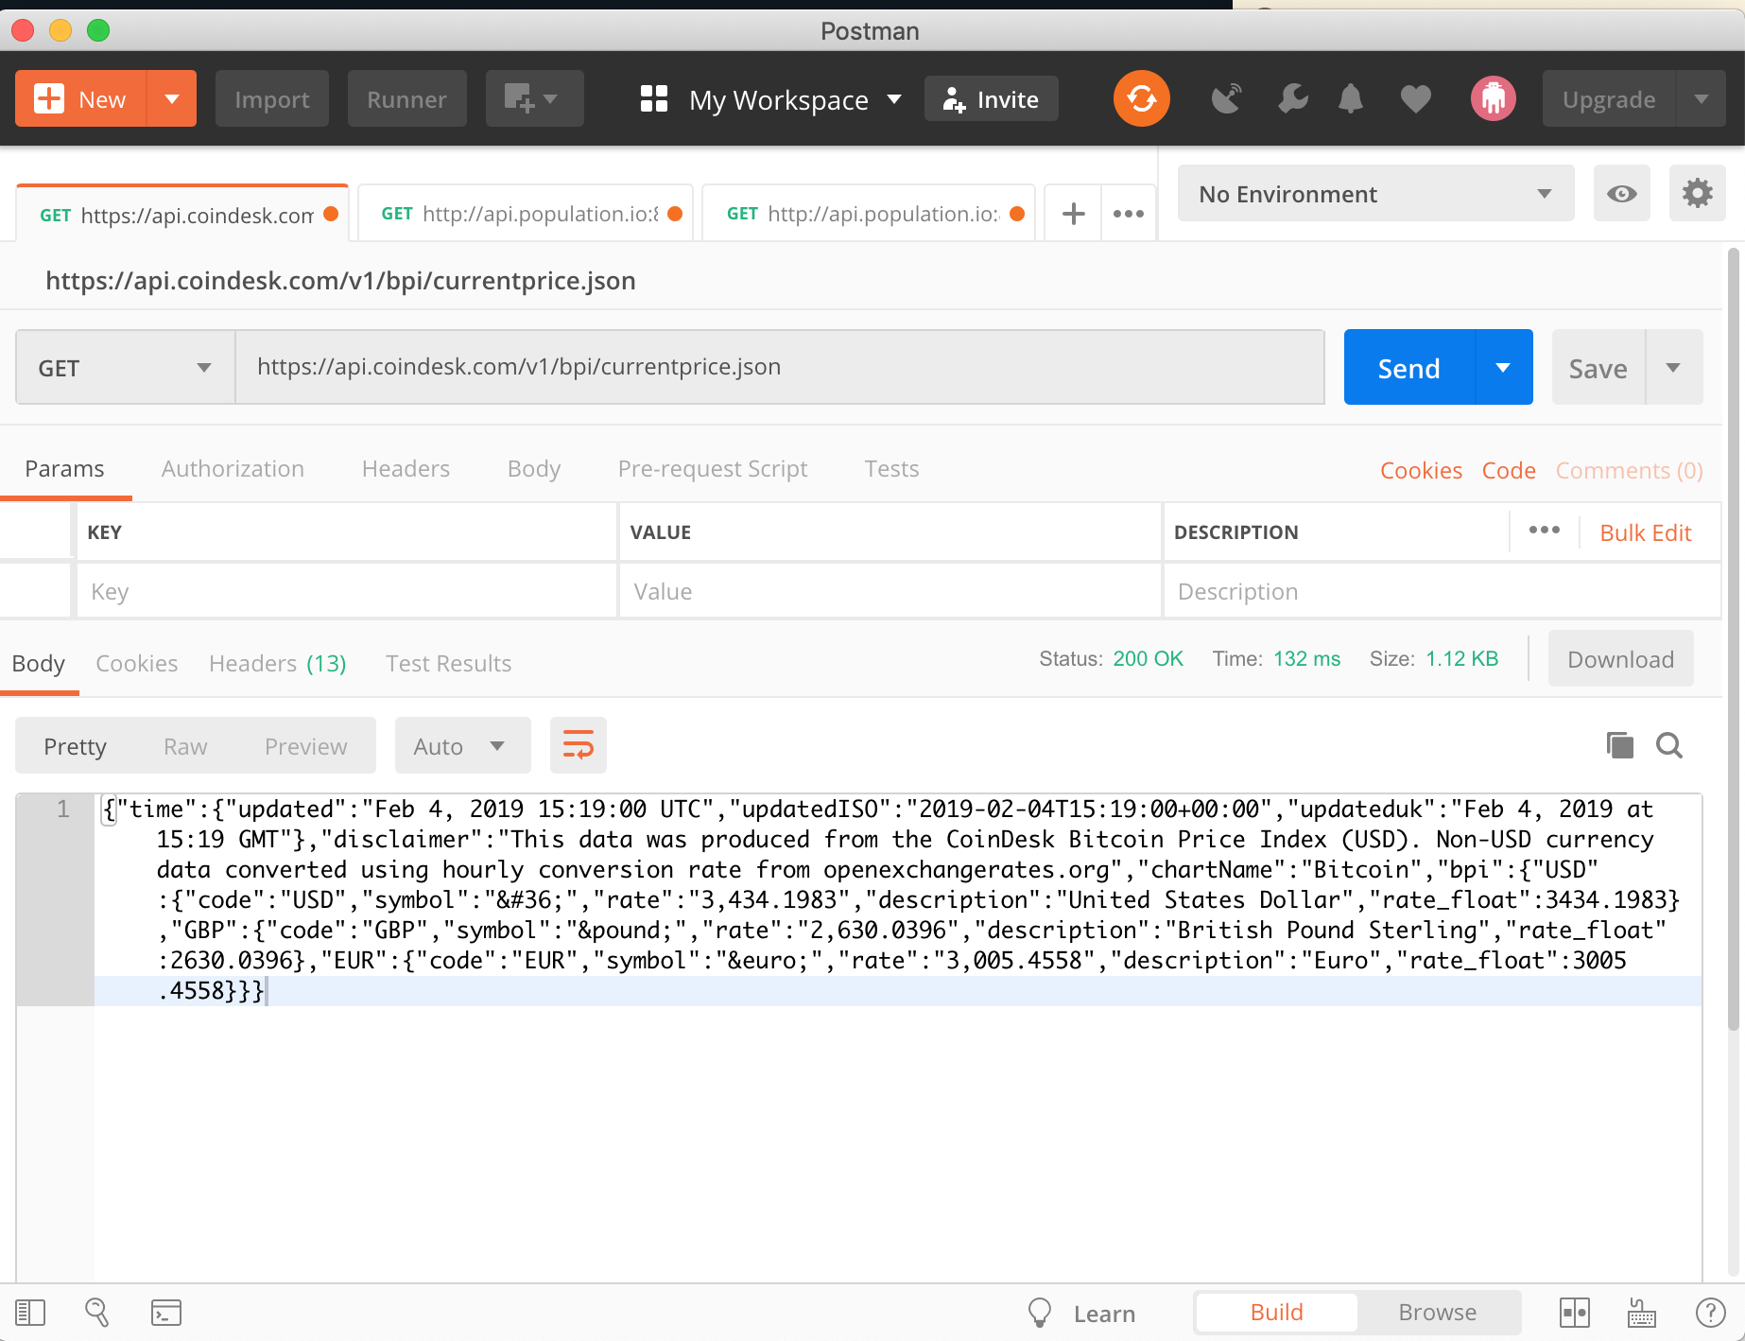

Here’s the second screenshot showing that the data is constantly updated so when you fetch data, it will show a current value.